C++文本管理项目
- 程序功能:
以 文本输入输出(ofstream和ifstream) 形式为基础，
程序拥有对文本进行创建，查找，更新，删除的功能

- 代码结构UML :
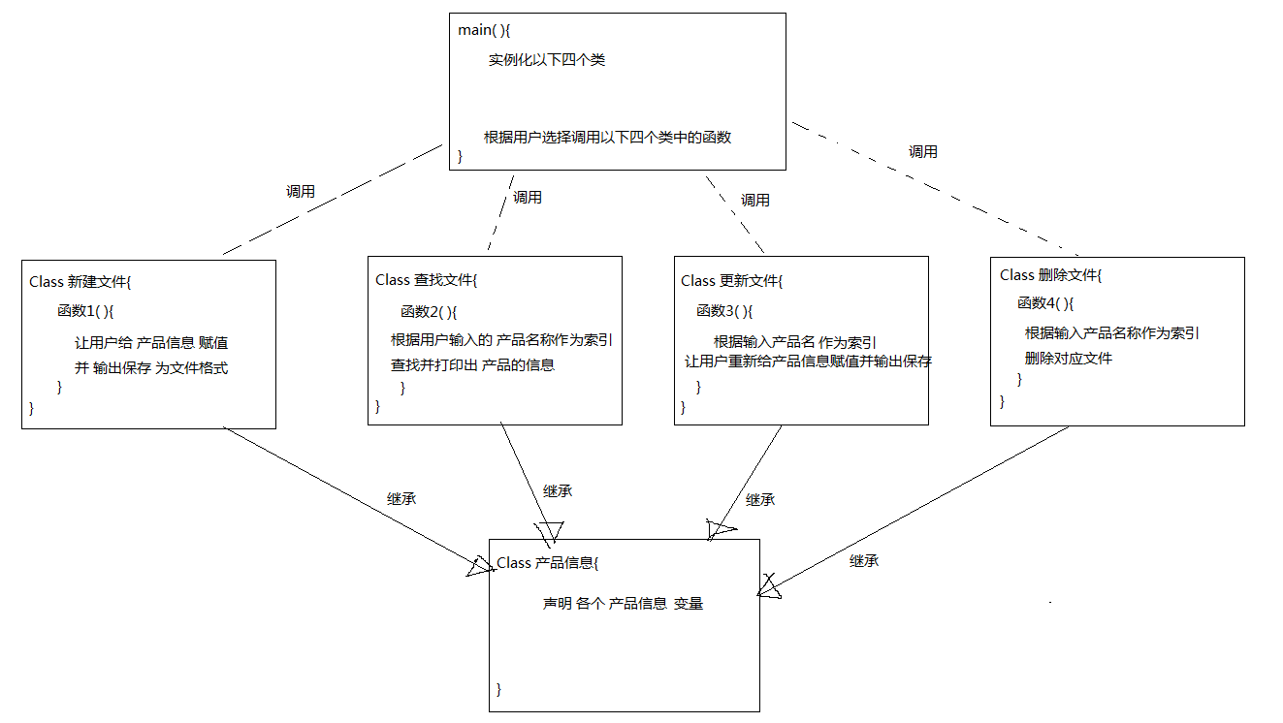

- 代码

#include "stdafx.h"
#include <iostream>
#include <string>
#include <fstream>
#include <cstdlib>
#include<stdio.h>
#include<conio.h>
using namespace std;

class product_Information{
protected:
char Product_Name[100];
string Product_ID;
string Manufacture_date;
float price;
string Brand;
string Expiary_Date;
char confirmation;
};

class add_Product :public product_Information{
public:
void function1(){
//让用户给变量赋值
cout << "please enter Product_Name" << endl;
cin >> Product_Name;
cout << "please enter Product_ID" << endl;
cin >> Product_ID;
cout << "please enter Manufacture_date" << endl;
cin >> Manufacture_date;
cout << "please enter price (Only integer or decimal number allowed!)" << endl;
cin >> price;
cout << "please enter Brand" << endl;
cin >> Brand;
cout << "please enter Expiary_Date" << endl;
cin >> Expiary_Date;
cout << "Confirm add this stock?(Enter Y to confirm)" << endl;
cin >> confirmation;
if (confirmation == 'Y'){
//输出变量到File Output
ofstream outputFile(Product_Name);
outputFile << "Product_Name : " << Product_Name << endl;
outputFile << "Product_ID : " << Product_ID << endl;
outputFile << "Manufacture_date : " << Manufacture_date << endl;
outputFile << "price : " << price << endl;
outputFile << "Brand : " << Brand << endl;
outputFile << "Expiary_Date : " << Expiary_Date << endl;
cout << "File is added to the Same Directory as this cpp file" << endl;
}
else
{
cout << "add_Product Failed" << endl;
}
}
};

class search_Product :public product_Information{
public:
void function2(){
while (confirmation != 'N'){
cout << "please enter Product_Name" << endl;
cin >> Product_Name;
//根据输入索引打印文件内容
ifstream inputFile;
inputFile.open(Product_Name);//打开文件
if (inputFile.is_open()){
cout << inputFile.rdbuf(); //.rdbuf()是ifstream好用的打印文件全部内容的函数
}
else{
cout << "Error occured when opening file " << Product_Name << endl;
}
cout << "Search Again?(Enter N to exist)" << endl;
cin >> confirmation;
}
}
};

class edit_Product :public product_Information{
char changeConfirmation;
public:
void function3(){ //无法实现用户指定修改，只能让用户全部重新输入
while (confirmation != 'N'){
cout << "please enter Product_Name you want to update" << endl;
cin >> Product_Name;
//根据输入索引打印文件内容
ifstream inputFile;
inputFile.open(Product_Name);//打开文件
if (inputFile.is_open()){
cout << "please enter the new Product_ID" << endl;
cin >> Product_ID;
cout << "please enter the new Manufacture_date" << endl;
cin >> Manufacture_date;
cout << "please enter the new price (Only integer or decimal number allowed!)" << endl;
cin >> price;
cout << "please enter the new Brand" << endl;
cin >> Brand;
cout << "please enter the new Expiary_Date" << endl;
cin >> Expiary_Date;
cout << "Confirm change this stock?(Enter Y to confirm)" << endl;
cin >> changeConfirmation;
if (changeConfirmation == 'Y'){
//输出变量到File Output
ofstream outputFile(Product_Name);
outputFile << "Product_Name : " << Product_Name << endl;
outputFile << "Product_ID : " << Product_ID << endl;
outputFile << "Manufacture_date : " << Manufacture_date << endl;
outputFile << "price : " << price << endl;
outputFile << "Brand : " << Brand << endl;
outputFile << "Expiary_Date : " << Expiary_Date << endl;
cout << "Change is made to file : " << Product_Name << endl;
break;
}
else
{
cout << "Change is not made to file : " << Product_Name << endl;
break;
}
}
else{
cout << "Error occured when opening file " << Product_Name << endl;
}
cout << "Search Again?(Enter N to exist)" << endl;
cin >> confirmation;
}
}
};

class delete_Product :public product_Information{
public:
void function4(){
cout << "please enter Product_Name you want to delete" << endl;
cin >> Product_Name;
cout << "Do you confirm delete file " << Product_Name << " ? (Y for confirm)" << endl;
cin >> confirmation;
if (confirmation == 'Y'){
remove(Product_Name); //.remove()的参数是char类型，不可以是string类型
cout << "File " << Product_Name << " removed" << endl;
}
else{
cout << "Change is not made to file : " << Product_Name << endl;
}
}
};

void main()
{
int functionChoose=0;
add_Product myAdd;
search_Product mySearch;
edit_Product myEdit;
delete_Product myDelete;
cout << "Choose Function number 1 to 4 :" << endl;
cout << "Enter 1 ---> Create a new product description file" << endl;
cout << "Enter 2 ---> Search for a product description" << endl;
cout << "Enter 3 ---> Update a product description file" << endl;
cout << "Enter 4 ---> Delete a product description file" << endl;
cout << "Enter 5 ---> Quit program" << endl;
cin >> functionChoose;
while (functionChoose != 1 || 2 || 3 || 4|| 5){
if (functionChoose == 1){
myAdd.function1();
break;
}
else if (functionChoose == 2){
mySearch.function2();
break;
}
else if (functionChoose == 3){
myEdit.function3();
break;
}
else if (functionChoose == 4){
myDelete.function4();
break;
}
else if (functionChoose == 5){
break;
}
else
{
cin.clear();//cin.clear()和cin.sync()连用的作用是 清除缓存区中上一次cin的输入值，
cin.sync();//否则如果有人 输入超出int范围的数，这里会进入无限循环
cout << "Invalid input Please select again" << endl;
cin >> functionChoose;//重新cin值
}
}
system("pause");
}

